**HIVE MINI PROJECT 2**

Objective - The assignment is meant for you to apply learnings of the module on Hive on a real-life dataset. One of the major objectives of this assignment is gaining familiarity with how an analysis works in Hive and how you can gain insights from large datasets.

Problem Statement - New York City is a thriving metropolis and just like most other cities of similar size, one of the biggest problems its residents face is parking. The classic combination of a huge number of cars and a cramped geography is the exact recipe that leads to a large number of parking tickets.

In an attempt to scientifically analyse this phenomenon, the NYC Police Department regularly collects data related to parking tickets. This data is made available by NYC Open Data portal. We will try and perform some analysis on this data.

Download Dataset - https://data.cityofnewyork.us/browse?q=parking+tickets

Note: Consider only the year 2017 for analysis and not the Fiscal year.

create table parking

(

summons_number bigint,

plate_id string,

registration_state string,

plate_type string,

issue_date string,

violation_code int,

vehicle_body_type string,

vehicle_make string,

issuing_agency string,

street_code1 int,

street_code2 int,

street_code3 int,

vehicle_expiration_date int,

violation_location int,

violation_precinct int,

issuer_precinct int,

issuer_code int,

issuer_command string,

issuer_squad string,

violation_time string,

time_first_observed string,

violation_county string,

violation_front_opposite string,

house_number string,

street_name string,

intersecting_street string,

date_first_observed int,

law_section int,

sub_division string,

violation_legal_code string,

days_parking_in_effect string,

from_hours_in_effect string,

to_hours_in_effect string,

vehicle_color string,

unregistered_vehicle int,

vehicle_year int,

meter_number string,

feet_from_curb int,

violation_post_code string,

violation_description string,

no_standing_or_stopping_violation string,

hydrant_violation string,

double_parking_vio string

)

row format delimited

fields terminated by ','

location '/project2/data'

tblproperties("skip.header.line.count"="1");

create table parking_violation

(

Summons_Number bigint,

Plate_ID string,

Registration_State string,

Plate_Type string,

Issue_Date date,

Violation_Code int,

Vehicle_Body_Type string,

Vehicle_Make string,

Issuing_Agency string,

Street_Code1 int,

Street_Code2 int,

Street_Code3 int,

Vehicle_Expiration string,

Violation_Location int,

Violation_Precinct int,

Issuer_Precinct int,

Issuer_Code int,

Issuer_Command string,

Issuer_Squad string,

Violation_Time string,

Time_First_Observed string,

Violation_In_Front_of_or_Opposite string,

House_Number string,

Street_Name string,

Intersecting_Street string,

Date_First_Observed int,

Law_Section int,

Sub_Division string,

Violation_Legal_Code string,

Days_Parking_In_Effect string,

From_Hours_In_Effect string,

To_Hours_In_Effect string,

Vehicle_Color string,

Unregistered_Vehicle int,

Vehicle_Year string,

Meter_Number string,

Feet_From_Curb int,

Violation_Post_Code string,

Violation_Description string,

No_Standing_or_Stopping_Violation string,

Hydrant_Violation string,

Double_Parking_Violation string)

partitioned by (Violation_County string)

CLUSTERED BY (Violation_Code) sorted by (Violation_Code) INTO 8 BUCKETS

row format delimited

fields terminated by ','

tblproperties ("skip.header.line.count" = "1");

set hive.exec.dynamic.partition=true;

set hive.exec.dynamic.partition.mode=nonstrict;

set hive.enforce.bucketing = true;

insert into parking_violation

partition(Violation_County) Select

Summons_Number,

Plate_ID,

Registration_State,

Plate_Type,

Issue_Date,

Violation_Code,

Vehicle_Body_Type,

Vehicle_Make,

Issuing_Agency,

Street_Code1,

Street_Code2,

Street_Code3,

Vehicle_Expiration_date,

Violation_Location,

Violation_Precinct,

Issuer_Precinct,

Issuer_Code,

Issuer_Command,

Issuer_Squad,

Violation_Time,

Time_First_Observed,

Violation_front_Opposite,

House_Number,

Street_Name,

Intersecting_Street,

Date_First_Observed,

Law_Section,

Sub_Division,

Violation_Legal_Code,

Days_Parking_In_Effect,

From_Hours_In_Effect,

To_Hours_In_Effect,

Vehicle_Color,

Unregistered_Vehicle,

Vehicle_Year,

Meter_Number,

Feet_From_Curb,

Violation_Post_Code,

Violation_Description,

No_Standing_or_Stopping_Violation,

Hydrant_Violation,

Double_Parking_Vio,

Violation_County

from parking ;

The analysis can be divided into two parts:

Part-I: Examine the data

1. Find the total number of tickets for the year.

select count(distinct(summons_number)) from parking_violations;

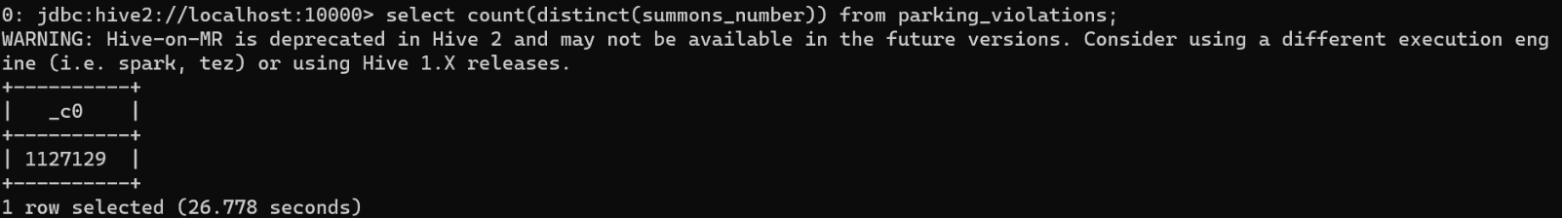

1. Find out how many unique states the cars which got parking tickets came from.

select count(distinct(registration_state)) from parking_violations;

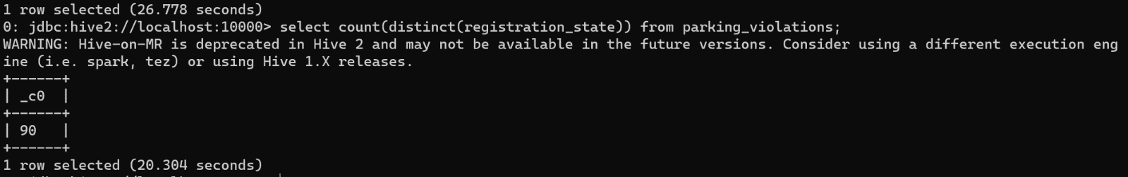

1. Some parking tickets don’t have addresses on them, which is cause for concern. Find out how many such tickets there are(i.e. tickets where either "Street Code 1" or "Street Code 2" or "Street Code 3" is empty )

SELECT COUNT(*)

FROM parking_violations

WHERE street_code1 IS NULL OR street_code2 IS NULL OR street_code3 IS NULL;

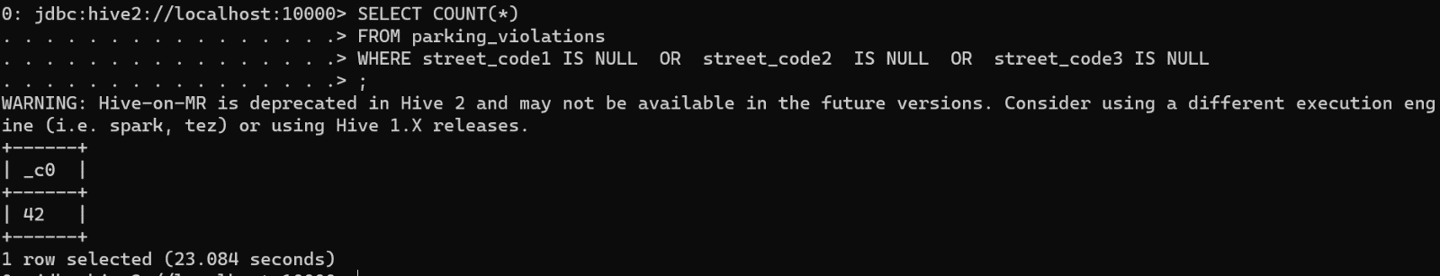

Part-II: Aggregation tasks

1. How often does each violation code occur? (frequency of violation codes - find the top 5)

select violation_code, count(violation_code) as frequency

from parking_violations

group by violation_code

order by violation_code desc

limit 5;

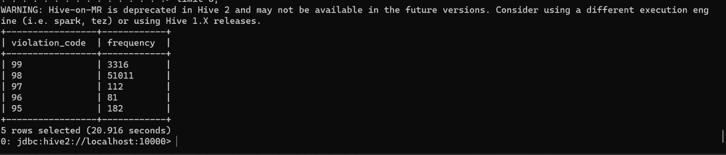

1. How often does each vehicle body type get a parking ticket? How about the vehicle make? (find the top 5 for both)

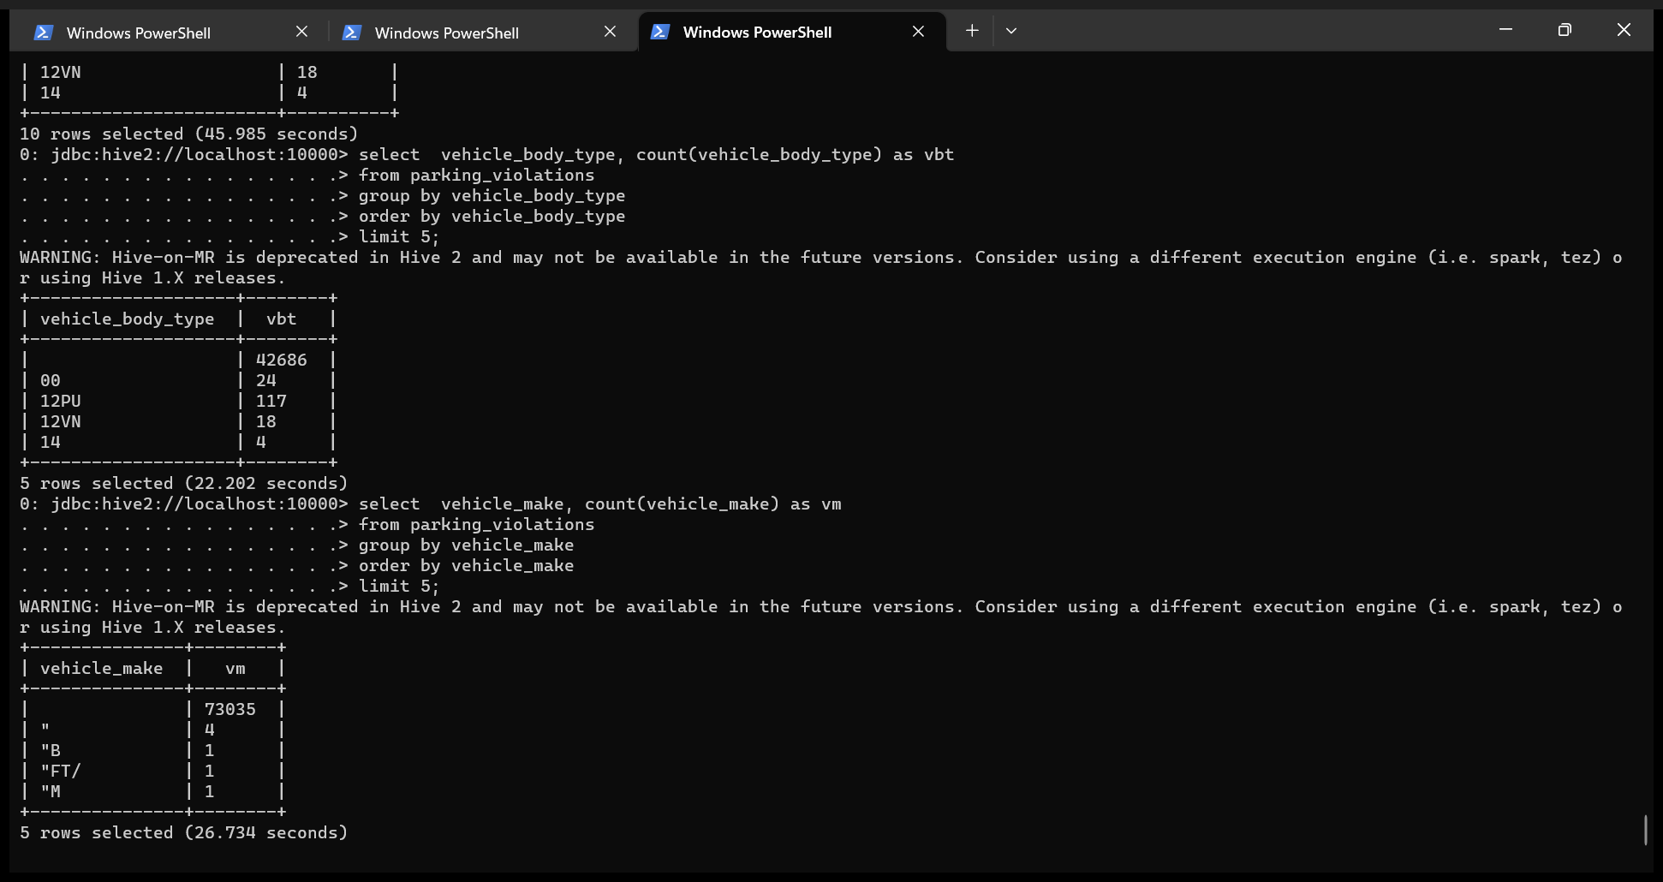

3.) A precinct is a police station that has a certain zone of the city under its command. Find the (5 highest) frequencies of:

a.) Violating Precincts (this is the precinct of the zone where the violation occurred)

b.) Issuer Precincts (this is the precinct that issued the ticket)

SELECT s.Violation_Precinct, s.vps

FROM (

SELECT Violation_Precinct, COUNT(Violation_Precinct) AS vps

FROM parking_violations

GROUP BY Violation_Precinct

) s

ORDER BY s.vps DESC

LIMIT 5;

SELECT s.Issuer_Precinct, s.vp

FROM (

SELECT Issuer_Precinct, COUNT(Issuer_Precinct) AS vp

FROM parking_violations

GROUP BY Issuer_Precinct

) s

ORDER BY s.vp DESC

LIMIT 5;

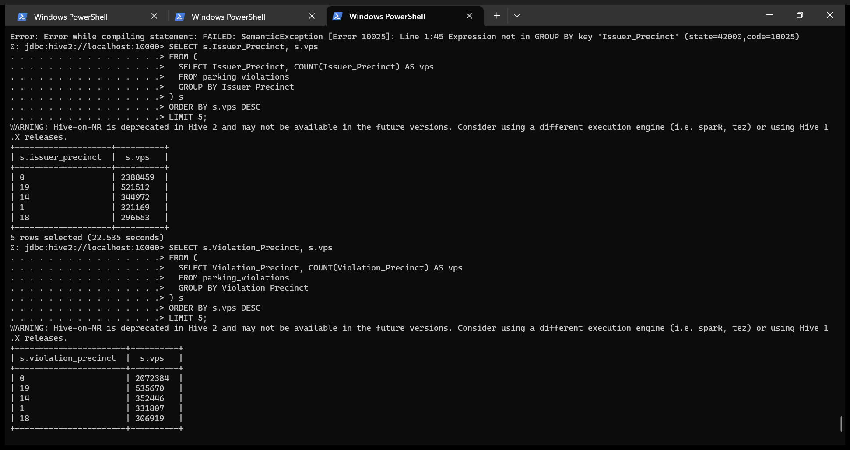

4.) Find the violation code frequency across 3 precincts which have issued the most number of tickets - do these precinct zones have an exceptionally high frequency of certain violation codes?

select Issuer_Precinct,Violation_Code, count(*) as Violation_code_frequency from parking_violations group by Issuer_Precinct, Violation_Code order by Violation_code_frequency desc limit 8;

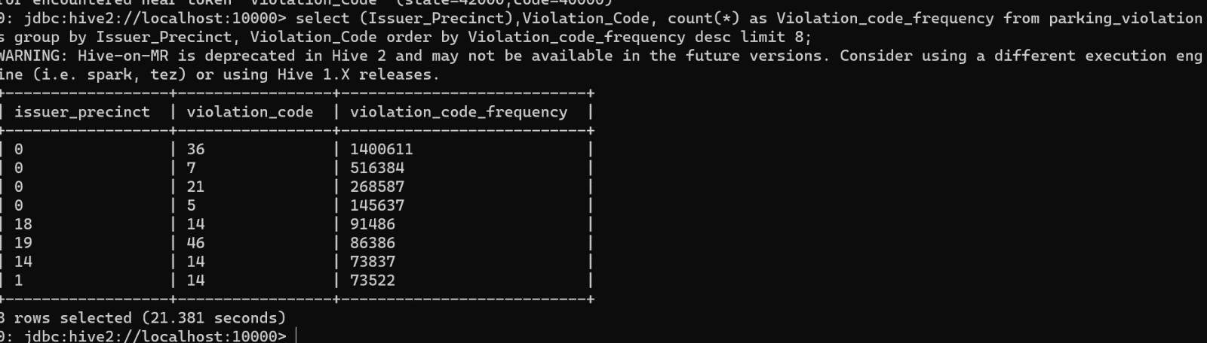

We will not be considering 0. Therefore 18,19,14 are the three issuer precincts which have the maximum number of violations. Lets dive into the Issuer Precincts one by one.

select Issuer_Precinct,Violation_Code, count(*) as Violation_code_frequency from parking_violations where issuer_precinct = 18 group by Issuer_Precinct, Violation_Code order by Violation_code_frequency desc limit 8;

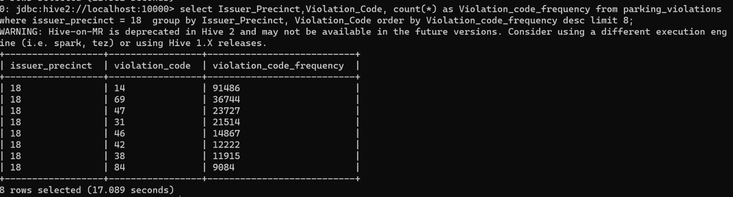

select Issuer_Precinct,Violation_Code, count(*) as Violation_code_frequency from parking_violations where issuer_precinct = 19 group by Issuer_Precinct, Violation_Code order by Violation_code_frequency desc limit 8;

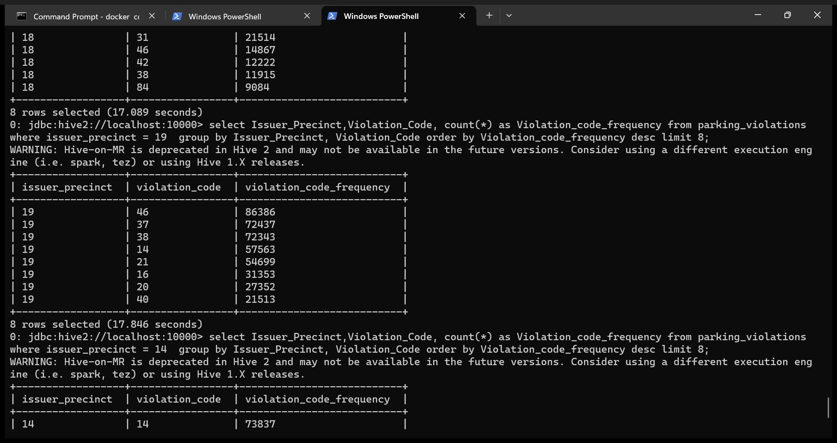

select Issuer_Precinct,Violation_Code, count(*) as Violation_code_frequency from parking_violations where issuer_precinct = 14 group by Issuer_Precinct, Violation_Code order by Violation_code_frequency desc limit 8;

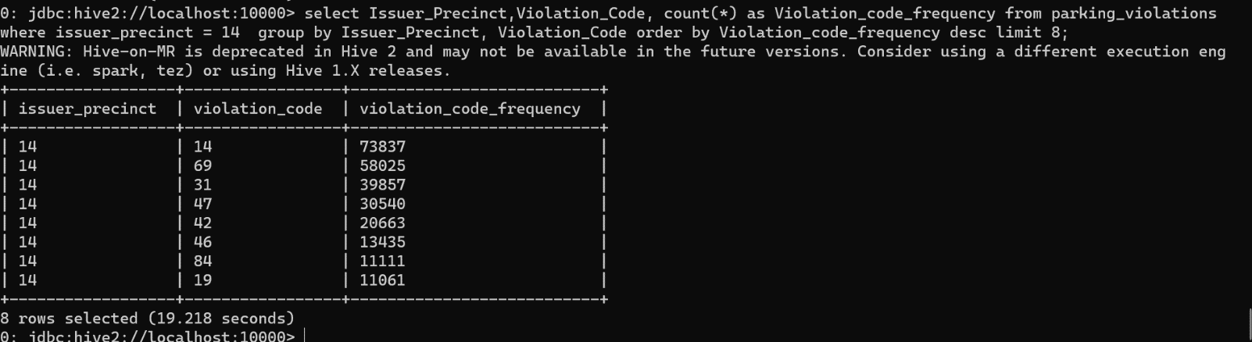

**🡺Common codes accross precincts**

select Issuer_Precinct,Violation_Code, count(*) as Violation_code_frequency from parking_violations where issuer_precinct in (18,19,14) group by Issuer_Precinct, Violation_Code order by Violation_code_frequency desc limit 8;

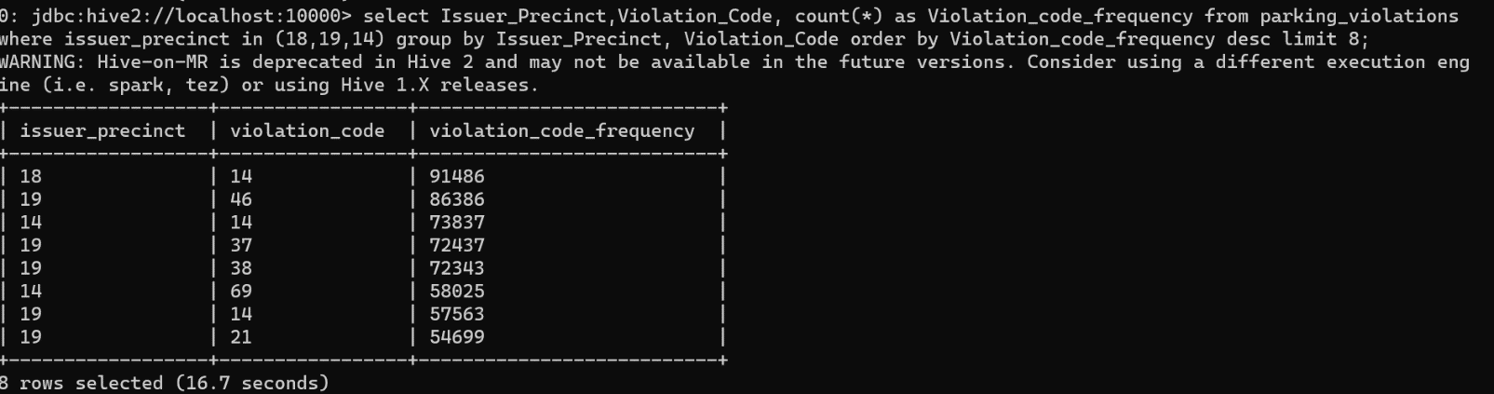

5.) Find out the properties of parking violations across different times of the day: The Violation Time field is specified in a strange format. Find a way to make this into a time attribute that you can use to divide into groups.

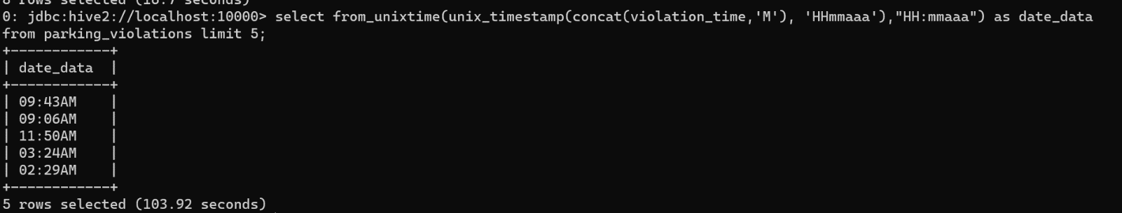

6.) Divide 24 hours into 6 equal discrete bins of time. The intervals you choose are at your discretion. For each of these groups, find the 3 most commonly occurring violations

create view vw_parking_violations_partitoned_2017

partitioned on (Violation_Code)

as

SELECT

Summons_Number,

Violation_Time,

Issuer_Precinct,

case

when substring(Violation_Time,1,2) in ('00','01','02','03','12') and upper(substring(Violation_Time,-1))='A' then 1

when substring(Violation_Time,1,2) in ('04','05','06','07') and upper(substring(Violation_Time,-1))='A' then 2

when substring(Violation_Time,1,2) in ('08','09','10','11') and upper(substring(Violation_Time,-1))='A' then 3

when substring(Violation_Time,1,2) in ('12','00','01','02','03') and upper(substring(Violation_Time,-1))='P' then 4

when substring(Violation_Time,1,2) in ('04','05','06','07') and upper(substring(Violation_Time,-1))='P' then 5

when substring(Violation_Time,1,2) in ('08','09','10','11') and upper(substring(Violation_Time,-1))='P'then 6

else null

end as Violation_Time_bin,

Violation_Code

from parking_violations

where

Violation_Time is not null

or (length(Violation_Time)=5 and upper(substring(Violation_Time,-1))in ('A','P')

and substring(Violation_Time,1,2) in ('00','01','02','03','04','05','06','07', '08','09','10','11','12'));

select Violation_Code,Violation_Time_bin, count(*) frequency_violation from vw_parking_violations_partitoned_2017 group by Violation_Code,Violation_Time_bin limit 5;

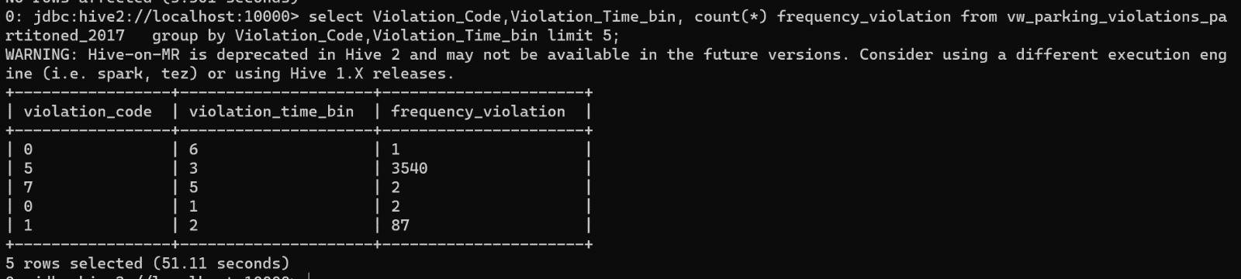

select Violation_Code,count(*) frequency_violation from vw_parking_violations_partitoned_2017 where Violation_Time_bin =1 group by Violation_Code order by frequency_violation desc limit 3;

similar way applying on all bins

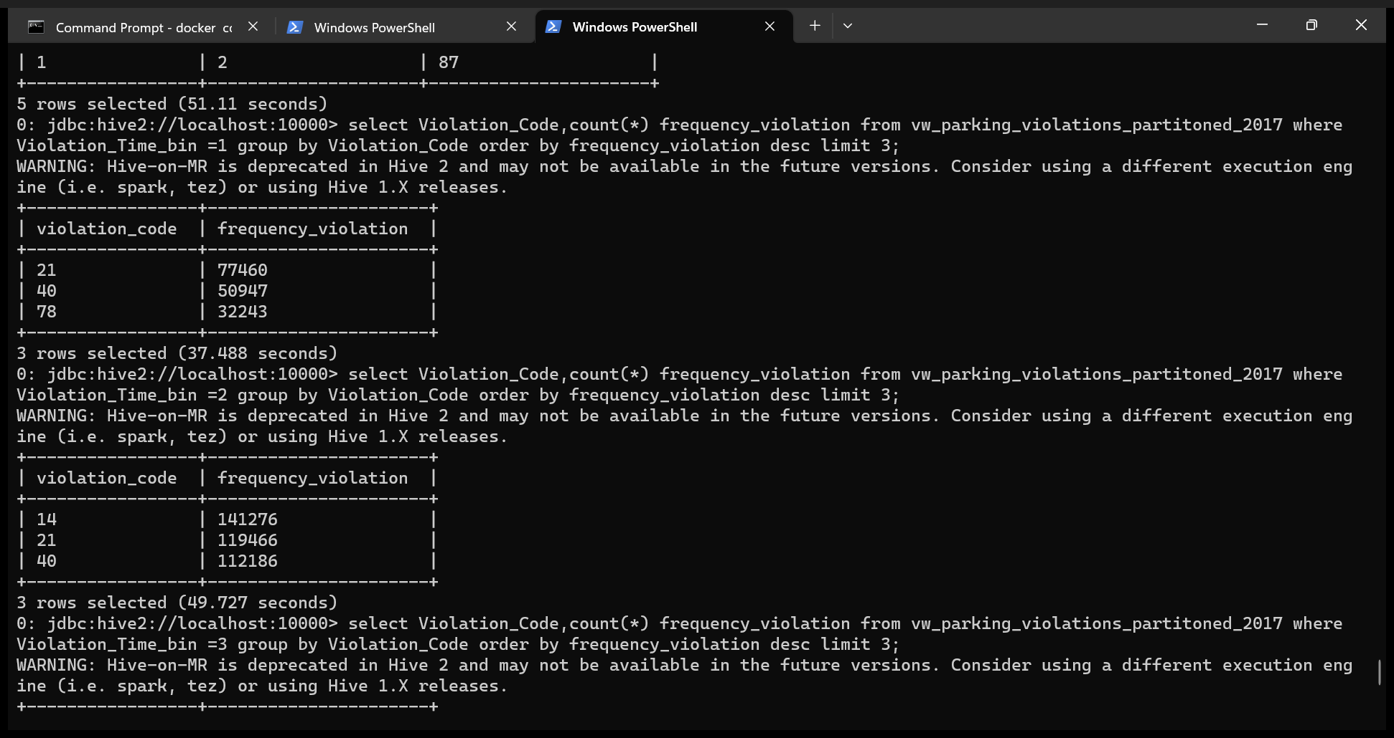

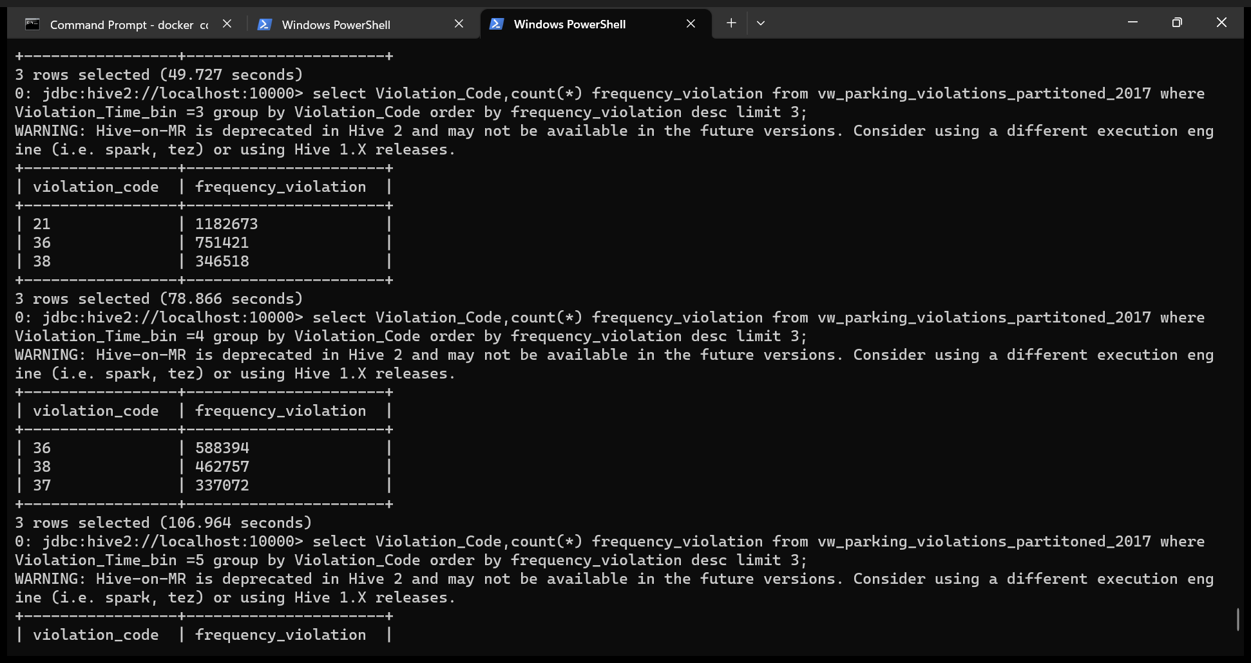

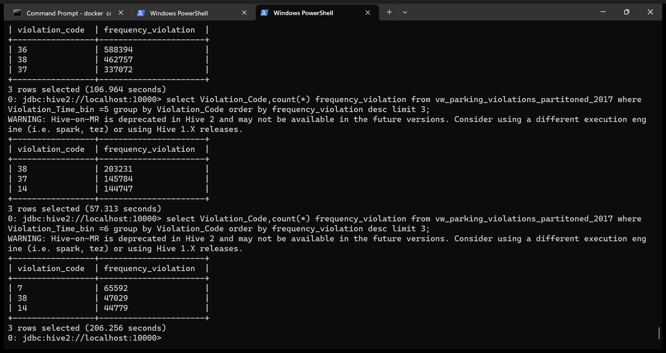

7.) Now, try another direction. For the 3 most commonly occurring violation codes, find the most common times of day (in terms of the bins from the previous part)

